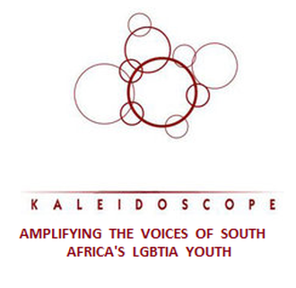

An umbrella group encompassing a growing number of LGBTIA (Lesbian, Gay, Bisexual, Transgender, Intersex, Asexual) student solidarity organisations in South African tertiary institutions.
Website - www.kaleidoscopenetwork.weebly.com
Facebook Page - www.facebook.com/kaleidoscopenetwork
MSN Messenger - kaleidoscopenetwork@live.co.za
Twitter - @Kaleidoscopenet
E-mail - kaleidoscopenetwork@live.co.za
STATEMENT ON PINKWASHING AND APARTHEID ISRAEL 8 March 2012
We as the Kaleidoscope Youth Network condemn Israeli Apartheid, and stand in support of the IAW as it sets out to raise awareness around issues of gross human rights violations. We support the boycott of Israel and call on all who are in favour of human rights to stand together as we lend a hand to those in needs through our actions. Our country has been through trying times where discrimination, such as that displayed in Israel has robbed people of their dignity, insulted the concept of humanity, and ravaged the notion of community. We cannot be silenced by a regime which chooses to sugar-coat its injustices. We as Lesbian, Gay, Bisexual, Transgender (and Transsexual), Intersex , Asexual(LGBTIA) youth of South Africa along with our Allies are guided by the Constitution of South Africa regarding human dignity, the achievement of equality and the advancement of human rights and freedoms. And so it is our belief that everyone should enjoy the rights that we are privileged to have. For too long have we been silent, for too long and no more.
We are particularly opposed to the manner in which 'pinkwashing' is implemented internationally, by painting Israel as a 'haven' for LGBT persons whilst Israel commits gross human rights violations in its backyard. We find the calls for queer persons to support Israel in the name of gay rights alone offensive and urge South African queer persons to abstain from supporting apartheid Israel. To buy into pinkwashing is to buy into silencing and oppression. We salute those who support queer Palestinians' calls for support on an international level. We are with you, and all Palestinians.
Aluta Continua
C. Anzio Jacobs (National Convenor)
T White (National Vice Convenor)
Read on behalf of Kaleidoscope Youth Network, a collective of LGBTIA organisations for students in tertiary education.

